
DELHI PUBLIC SCHOOL, HAPUR
Session 2025-26
DPS CODERZ LEAGUE COMPUTER COMPETITION
Class – III
RESULT DECLARATION

Students’ Name | Class & Section | Position | Winners
Aarohi Jindal | III A | I | 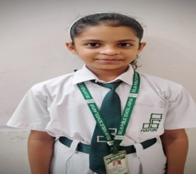
Anaya Karanwal | III A | II | 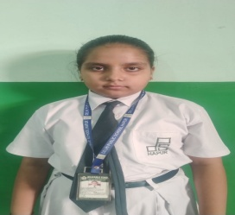
Amayra Karanwal | III A | II | 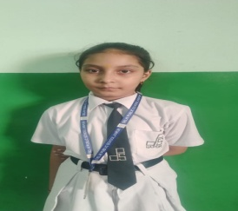
Vatsal | III B | I | 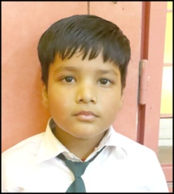
Shivansh Kumar | III B | II | 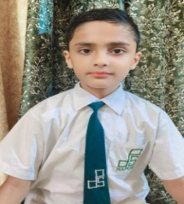
Aadhya Aggarwal | III C | I | 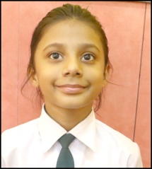
Sukhnoor Singh Kalsi | III C | I | 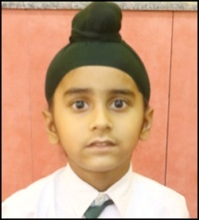

Naomika Arora | III C | II | 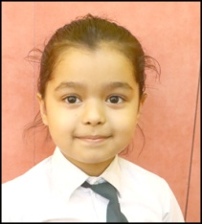
Atharv Nirwan | III C | III | 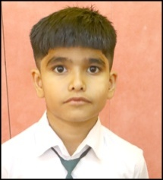
Hinaya Arora | III D | I | 
Kashvi | III E | I | 